The English Junior Coaches and Organisers Association (EJCOA)
STARTER PACK FOR SCHOOLS

Introduction
Welcome to this starter pack for schools. If you are thinking of forming a chess club at your school or among children, we hope you will find our advice and suggestions useful.
EJCOA is a newly formed body of experienced English chess coaches and organisers and currently comprises over 300 members, all of whom are dedicated to developing junior chess.

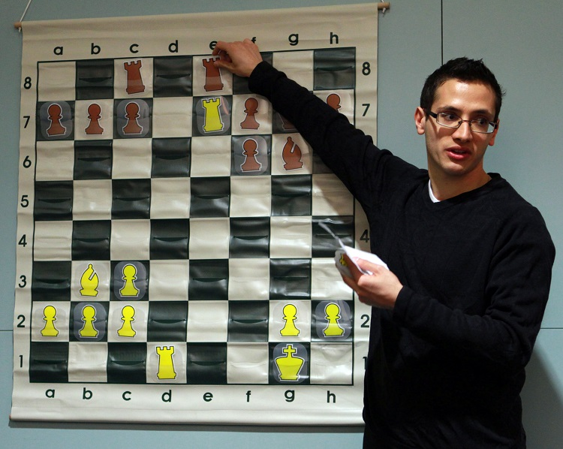
EJCOA includes more than 300 experienced coaches and junior organisers.
CONTENTS
1 Why Chess?
2 Junior Chess Events & Organisations
3 Setting Up a Chess Club
4 Resources
1 Why Chess?
Chess is the perfect game for children to learn and play. Through chess, children learn to win and lose with equal grace. They learn transferable skills such as concentration and strategic thinking. They learn to look ahead, to anticipate and to be circumspect when necessary. They learn to think before acting.
There can be no better gift that you can bestow on your children than to start a chess activity at your school or to form a club.
Above all, chess is fun!

2 Junior Chess Events & Organisations
To begin, we map out the current junior chess scene in England.
The largest junior chess tournaments and coaching organisations aside from EJCOA are:
- The English Chess Federation. The nationally recognised body for chess in England, the ECF organises national championships for individual juniors, both separately and as part of the annual British Championships, and a range of school teams competitions.

- Chess in Schools and Communities (CSC). A UK-wide chess educational charity that provides chess coaching in hundreds of state schools nationwide. It provides curriculum lessons and after-school clubs, also providing chess sets for school use.

- English Primary School Chess Association (EPSCA). The organisation’s flagship events are the National Schools Under 9 and Under 11 team championships, which start in January with zonal sections and move forward to three semi-finals and a final in July consisting of eight teams. There are also individual events that allow for norms to be achieved, which allow children to qualify for the EPSCA England team.

- Delancey UK Chess Challenge (UKCC). This is an exceptionally popular event for individual children to compete in, which starts with a school section and widens out into a county, national and then final stage.

- The London Junior Chess Championships. Builds in the Autumn Term via a series of qualifying events to an exceptionally strong group of age-restricted championships at the end of each year.

- The South of England Chess Championships: A large and traditionally strong event, which includes the national squad closed championships. Held annually at the end of January.

- The Junior 4 Nations Chess League (J4NCL): A popular and increasingly strong event for teams of four, based around junior clubs. Held periodically over weekends throughout the year at various locations around England.
There are countless other events for children held throughout the year. A reliable, continually updated list can be found here:
Calendar – English Chess Federation
Links to events and organisations:
EJCOA: EJCOA (ejogguide.co.uk)
The English Chess Federation: English Chess Federation
CSC: Chess in Schools and Communities
EPSCA: EPSCA
UKCC: Delancey UK Schools' Chess Challenge | Chess Competition for Schools (delanceyukschoolschesschallenge.com)
LJCC: London Junior Chess Championships (ljcc.co.uk)
South of England Junior Chess Congress - Home
Four Nations Chess League (4ncl.co.uk)

3 Setting up a Chess Club
In the next section we offer direct advice about setting up and maintaining a school chess club.
Please click on each link for information.

Coaching Advice
- Structure for a school club
- How to handle behaviour in a school club
- How to run an external junior tournament
- How to run an external junior club
- How to run an online training class
- How to set up your studies on Lichess
- Chess sets for school clubs and other equipment required
- Competing in a school team tournament

4 Resources

We are also able to offer introductory booklets to chess, which will help children, teachers and parents. This is a project sponsored by St. Catherine’s School in Bramley, Surrey, in partnership with the English Chess Federation. The booklets assume no knowledge of chess to begin with and will take you through to a good starting level.
You may download them here:
Chess products by EJCOA members listed in our constitution | EJCOA (ejogguide.co.uk)

She Plays To Win – A UK-wide Girls’ Chess project

More and more girls are taking up chess, and ‘She Plays To Win’ is a UK-wide Girls’ Chess project led by the England Women’s Olympiad team coach, International Master Lorin D’Costa. It is aimed at encouraging more girls to participate and learn chess in a fun environment.
The project offers 30 minutes’ free weekly group training and a tournament on the Lichess.org server afterwards.
lichess.org • Free Online Chess

‘She Plays To Win’ is open to all girls in primary, secondary or university (under 28) regardless of chess level or experience, and includes a group for beginners.
To sign up, parents just need to sign up here: https://www.sheplaystowin.co.uk/join-sptw
SPTW also has an online girls Primary and Secondary Schools League, sponsored by Pinpoint Learning.
This runs every half-term throughout the school year, and is free to enter. Girls from all schools are welcome.
E-mail Lorin D D’Costa at: sheplaystowinuk@gmail.com to enter your school.

Thank you for reading!

It pays to be simple at an early stage and we hope that you have found this starter pack helpful.
Please do contact us at the link below for more advice and information:
Contact | EJCOA (ejogguide.co.uk)

Robert Willmoth
Chair, EJCOA
June 2021

